ST. THOMAS TRAINING COLLEGE
(Approved by NCTE and Government of Kerala
Affiliated to the University of Kerala)

MANAGED BY
THE MAR THOMA CHURCH EDUCATIONAL SOCIETY
MUKKOLAKKAL, THIRUVANANTHAPURAM – 695 043
Tel: (0471)-2511101, (Principal), 2511102 (Office)
www.sttctvm.org
e-mail: sttctvpm@gmail.com

PROSPECTUS FOR TWO YEAR B.Ed DEGREE PROGRAMME 2026 - 2028
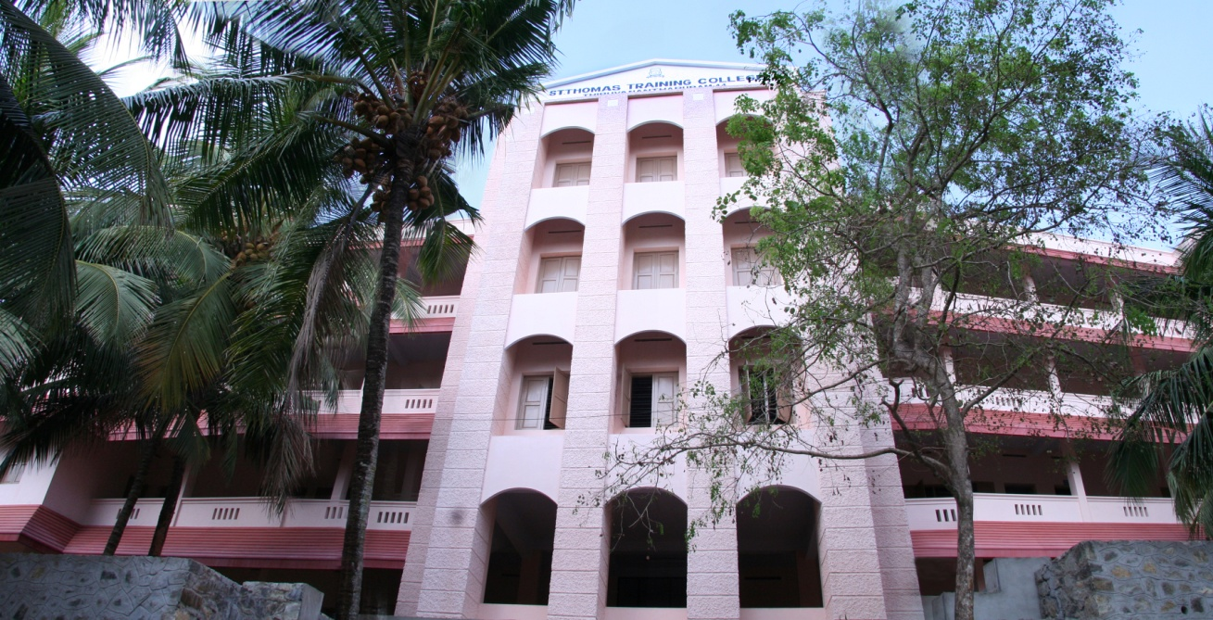

OPTIONAL SUBJECTS
- ENGLISH
- MATHEMATICS
- NATURAL SCIENCE
- PHYSICAL SCIENCE
- SOCIAL SCIENCE
ABOUT THE CAMPUS

The St. Thomas Training College (STTC) has been set up by the Mar Thoma Church Educational Society, a Society registered under the Travancore – Cochin Literary, Scientific and Charitable Societies Registration Act, 1055 as No.S.23 of 1966. STTC which strives to prepare teachers for teaching in the class rooms of tomorrow started functioning from July 2005.
The Society runs three prestigious Schools at its Campus in Mukkolakkal, Thiruvananthapuram viz, the St. Thomas Residential School, the St.Thomas Central School and the St.Thomas Higher Secondary School and the St. Thomas Institute for Science and Technology offering B.Tech & M.Tech Courses at Chanthavila, Kazhakuttam, Thiruvananthapuram and the St.Thomas Public School also at Chanthavila.

HOW TO APPLY
Application forms are available from the College Office on payment of Rs.500/- or can be downloaded from the Website www.sttctvm.org and hard copy to be given to the College with a payment mentioned above as Demand Draft or Cash.
ELIGIBILITY
- A Degree with 50% of Marks either in the Bachelor’s Degree and/or in the Master’s Degree in the subjects concerned.
- The minimum requirement of marks for admission to B.Ed course is 50% for Part III/50% in aggregate (Part I + Part II + Part III together) in Bachelor’s Degree (Science/Arts subjects) or 50% marks in Post Graduation in the concerned subject.
- Ranking of candidates shall be on the basis of marks obtained for Part III.
- Candidates who have taken their Degree from a University other than Kerala University should produce an Eligibility Certificate (from University of Kerala) and Migration Certificate (from the University where the candidate last attended the Qualifying Examination) at the time of admission.
FEES DETAILS
The tuition fee has to be paid at the time of admission and the withdrawal of a candidature during an academic year is not generally allowed. If a student has to withdraw for any reason, no amount will be refunded under any circumstances after the classes are started in the College. If a student provisionally admitted wants to withdraw from the admission with prior written intimation received prior to the reopening of the College, a minimum of 50 % of fees will be deducted.
Those who do not pay fees by the prescribed date are liable to lose the chance of getting admitted and then the seats are liable to be filled by other applicants or by late applicants.

****************************

